**Subject-Process Modeling &Simulation(PC-711/PC-711(A)**

**Assignment-I**

Q.1 What is the main difference between the lumped parameter model and the distributed parameter model?

Q.2 Consider a perfectly insulated, well-stirred tank, as shown in Figure 1.7, where a hot liquid stream at 75°C is mixed with a cold liquid stream at 15°C. Is it a lumped parameter system or a distributed parameter system? Explain why.

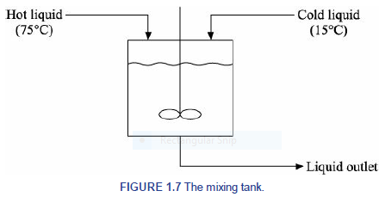

Q.3 Consider a conical receiver shown in Figure 1.8. The inlet and outlet liquid volumetric flow rates are *F*1 and *F*2, respectively.

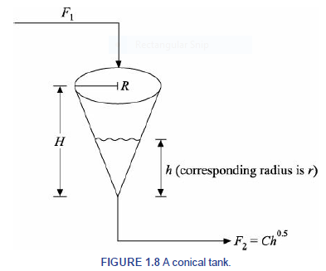

(i) Develop the model equation with necessary assumption(s) with respect to the liquid height *h*.

(ii) What type of mathematical model is this?

Q.4 Derive the dynamic mass balance equations for the following two simple cases (Figure 1.9

represents Case 1 and Figure 1.10 represents Case 2). Assume (i) a linear relationship between liquid level and flow rate through the outlet valve, and (ii) constant liquid density.

